Pro – spektif

On 12 June 2026 Ger planned to make the installation Pro-spektif, with 18 panels that are inspired by the prognose for the year 2260, as described in the following pages.

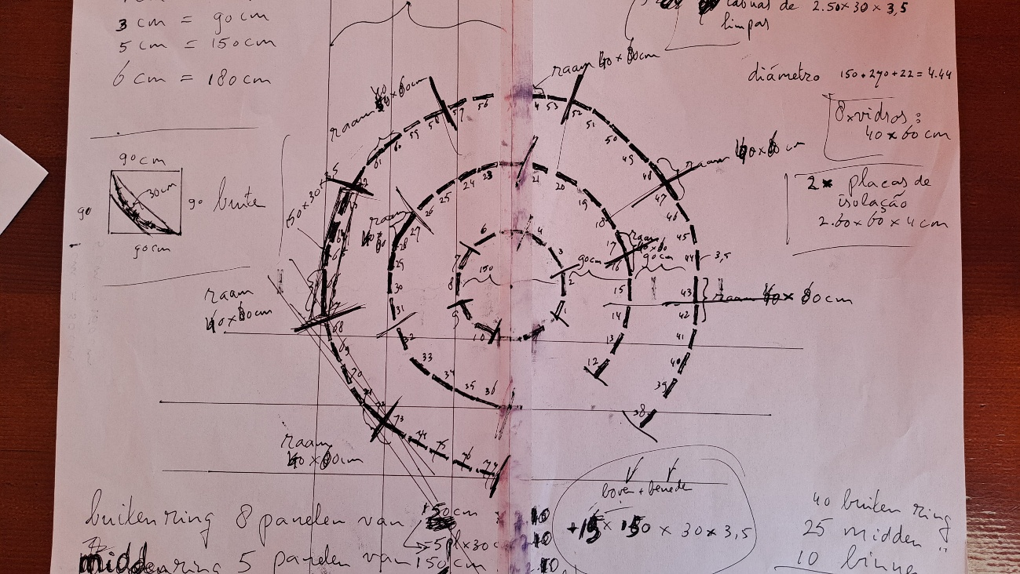

The inner circle has a diameter of 150 cm and exists of 5 panels of 60 cm wide and 2,4 m high. One panel has a window (60x80cm). Two panels show one of the world parts and one shows the oceans. Two are free for new inspiration.
The central circle has a diameter of 3,5m and exists of 5 panels of 1,5 m wide and 2,30 m high. Two panels have a window (60x80cm). Three panels show one of the world parts and one shows the oceans. One is still open.
The outer circle has a diameter of 4,5m and exists of 8 panels of 1,5 m wide and 2,20 m high. Three panels have a window (60x80cm). Three panels show one of the world parts and one shows the oceans. Four are still free for new inspiration.
He will try to make music and light projections that also are inspired on this document, part of the installation. Members of kollektif might contribute in the form of music, light, text, interviews, films, performances, presentations or otherwise. But also, other interested persons or organisations can propose activities too.
The aim of this work is to generate discussion and stimulate positive ideas for the future.
For this reason, ‘A sustainable world’ (this document) is published on the website www.kollektif.pt.

A sustainable world
After a combination of dramatic events, such as pandemics; decrease of the quality of sperm cells due to poisonous chemicals; climate change with drought, hurricanes, floods, higher sea levels; wars and positive and negative politics, the world reached finally a sustainable balance in the year 2260.
- Population and their environment
In the year 2260 there is a sustainable world with 2,5 billion people that live in areas decided by the decisionmakers (see chapter 6), taking in account the effects of climate change, attractiveness of cities and environment, food possibilities, availability of energy, space for cattle, and space for nature.
There are urban areas, parts with cattle for food, parts of nature with human entrance, and in all 6 regions huge parts of nature with very little limited human entrance in such a way that complete eco-systems can develop without any human influence.
There is an enormous space in cities for all kind of activities such as work, art, music, sport and games. People can choose to live in the most beautiful buildings and demolish the ugly ones. Monumental churches are used as music halls and exposition rooms.
And there is an enormous space for people that like to live in the countryside.
60.000.000 km2 of the world land has a natural ecology with no influence of humans except for science and for very limited tourism (as far as it does not do any harm).
- AI
During a period from 2025 until 2150 AI has been filled with the input from 10 billion people and after 2050 with a reduced number of humans, but with increased knowledge by AI. With assistance of AI an enormous amount of information can be combined in a way that a human brain never can.
With assistance of AI all scientific knowledge about influencing the human mind has been used to inform the population and to get support of the population.
With AI the knowledge in science, of environmental effects on humans, of energy efficiency, and knowledge in many other fields has led to new crucial knowledge to solve many problems that existed in the world in the year 2026. Knowledge that goes far beyond the possibilities of a human brain.
With AI medical science we now (the year 2260) can combine the functions of genes and peptides and solve many medical problems.
The world has been robotized with AI programs and many jobs that were fulfilled in 2026 are now executed by robots.
Humans now have much more time for other activities than labour.
There are many sport facilities available as well as music halls, art expositions, game halls, erotic centres, and museums.
- Energy
Energy is fully sustainable by nuclear fusion factories, sun power, wind, water and geothermal energy. With the assistance of AI an optimum balance is realized between hydro- sun- wind- nuclear (fusion) and other sources at the one side and the populated locations at the other side.
The energy costs are reduced to 25% of the costs in 2026.
In the year 2101 nuclear fusion reactors produced for the first time cheaper energy than wind energy. The waste of older nuclear reactors is used for fuel for nuclear fusion reactors.
- Food
Food is produced without chemicals that are unhealthy for the environment. Around populated areas there are locations for agriculture and for cattle.
Cattle are held in natural parks, with circumstances as close to normal natural behaviour as possible. Animals will be only killed in an animal friendly way, based on scientific research.
With the assistance of AI, a system has been developed in which every individual knows exactly which specific food is on a specific moment helpful for a good health.
- Nature
Biodiversity is now protected in the constitution.
In every part of the world there are huge parks where complete eco-systems can develop without any human interference. Science and limited possibilities to observe this natural environment are allowed.
Around the populated areas there are rings with agriculture and nature in which cattle can live in a natural way. These natural parks are open for public.
With assistance of AI new ways are found to reduce the number of poisonous materials in the environment (in water and land). For example, bacteria eat pfas in water and die.
50% of the oceans is free of human influences (including traffic), except for scientific research. Noise and pollution are very limited in the other 50%.

- Government
In 2080 after dramatic events worldwide, the ‘world constitution’ is determined.
There will be a new form of democracy, aimed on policies (strategies and tactical decisions) for the long term.
There will be only one army on the world.
2,5 billion people is 2.500 million humans.
Per million inhabitants there is one decisionmaker democratic appointed by elections in every part of the world (see below), so there will be 2.500 decisionmakers in the world. Decisionmakers are appointed for 10 years. Elections will be held based on one vote per adult individual human.
The tasks of the decisionmakers are:
- Organize the wellbeing of the population in the 6 parts of the world. The decisionmakers fulfil their work in their own part of the world but do this in agreement with the other world parts.
- Organise the wellbeing of the general world population in meetings between the decisionmakers from the different parts of the world.
- Inform the population.
- Obtaining support from the population.
- Selecting a world council of 90 members.

The decisionmakers need to fulfil to the following 6 criteria:
- Integrity
- Knowledge needed to serve the public interests by managing public services.
- Proven motivation to serve the public interests
- …
- …
- …
The criteria d, e and f can be decided in the democratic elections.
Every 5 year there is a referendum worldwide with different scenarios for an ideal society, after reviewing the population.
The decisionmakers take decisions with a majority of 2/3 of the votes.
The decisionmakers will be appointed in such a way that every year there will be some new members. Decisionmakers can create ministries and other organisation-forms within their part of the world.

The members of the world council are selected for 5 years. The world council has the monopoly for giving permission for the use of arms worldwide.
They are responsible for the police tasks as well as the military tasks.
They have an advisory task to support the decisionmakers in other matters.

The members take decisions with 2/3 of the votes (67 members must support the decisions).
They will be appointed in such a way that every year there will be some new members.
The maximum amount of council members in one world part is 30. The reason for this is that otherwise the world power would be too much in one part of the world. The minimum amount is 5 members to avoid being overpowered by other world parts.

Members of the world council earn 25 times the basic amount (see chapter 8), decisionmakers 20 times. All other salaries in the world are not higher than 15 times the basic amount.

- Society
In the constitution is stated that all humans have equal basic rights. There are independent courts and freedom of press is guaranteed.
Basic school is free for all children with classes of at maximum 25 children.
Higher education is free of charge and with the assistance of AI linked to the competences of individual persons.
Universities (research and education) are financed by the government, and studies are free of charge.
Medical and social care are free.
For families with 1 or 2 children all costs are compensated: creche, school, medical costs, loss of salary during pregnancy and the first year of the child. Families do not receive compensations for the third child or following children.
With use of AI many diseases and medical problems that were a burden in 2026, are absent in 2260.
Gene technology (for example crispr/cas) with assistance of AI, new knowledge of functions of different combinations of hormones with assistance of AI, and many other scientific developments has led to a healthier population that live on average 20 years longer than in 2026.
Viruses are reduced by genetic manipulation: they are genetic modified and die.
There is no poverty anymore in the world.
The costs for military and police tasks are since 2026 reduced to 20 %.
Families that had to leave areas are fully compensated with an average house suitable for 4 persons on (as far as they would like it) minimum 500 m2 land in any populated part of the world, with free education and/or a job that fits to the competences of the individual person.
Poetin, Trump, Netanyahu and his minister Ben-Gvir are convicted in 2034 by the International Court of Justice in Den Hague for war crimes. Trump died before the verdict, Netanyahu got Alzheimer and Poetin and Gvir died in prison.
But from 2034 the international law is leading again for government.

- Economy
The economy is highly strengthened using AI. Many tasks are fulfilled with robots or are realised with far more efficiency than in 2026. There is much more time for other pleasures than work.

Personnel is very scarce and therefore labour is very valuable.
There is one currency in the world: the dollar. This has made the financial systems far cheaper. And it has an enormous effect on administrative and other trade costs. Since there is only one currency prices for consumers reduced.
Every individual will receive a basic amount, enough to pay all basic costs of life.
People can earn extra income with work. Organisations only need to pay salaries above this basic amount.
Entrepreneurs may earn at maximum 15 times the basic amount. Employees in organisations earn salaries at maximum 15 times the basic amount. This is for 75% based on the impact of their tasks on the realisation of the goals of the organisation, added with 0% - 25% based on the contribution that the individual or organization has for society.
All salaries are taxed with 30 % to pay the governmental costs.
Energy is very cheap. For 2,5 billion people it was (with the assistance of AI) possible to make an energy plan for worldwide use of sustainable sources.
Housing for individuals as well as for organisations is very cheap. There are too many buildings, so already many are demolished and re-used, and more will be demolished in the future.

The 6 World parts
In 2026 there were 8,5 billion people
- Asia
- The current amount of the population in Asia is 4.900.000.000
- This is 58% of the world population.
- About 55% live in cities
- The total land surface is around 30.000.000 km²

Asia has in 2260 1,5 miljard human (60% van 2,5 miljard)
In Asia 1500 decisionmakers are democratic elected and 30 council members.

15.000. 000 km² is nature with very little limited human entrance (in such a way that nature can develop without any human influence).

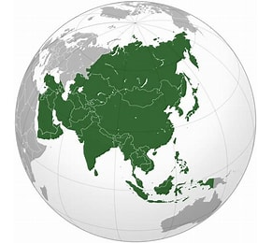

- Oceania (Australia, New Zealand, Melanesie,Polynesie, Micronesia)
- The current population of is 47.000.000
- This 0,55% of the world population.

Oceania has a population of 15 million (0,6 % of 2,5 billion)

80% of the territory is nature with very little limited human entrance (in such a way that nature can develop without any human influence).
In Oceania 15 decisionmakers are democratic elected and 5 council members.

Oceania has an extra responsibility for the oceans worldwide.

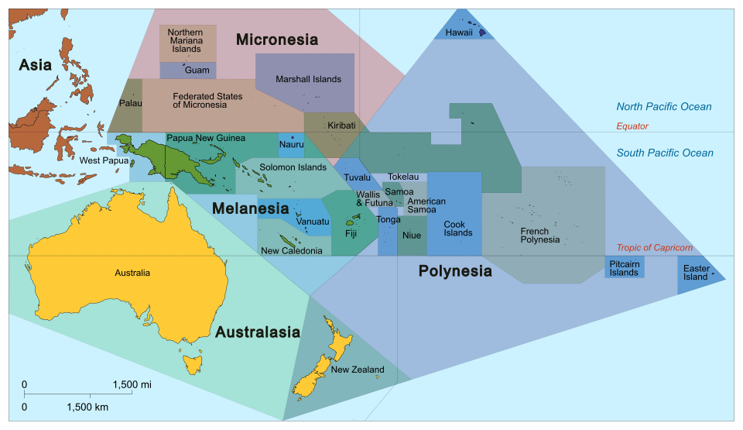

- Africa
- The population of Africa is in 2026: 1.600.000.000.
- This 19% of the world population.
- The total land surface is around 30.000.000.
- 46% of the population live in 2026 in cities.

Africa has in 2260 a population of 500 million humans (20% of 2,5 billion).

15.000.000 km² is nature with very little limited human entrance (in such a way that nature can develop without any human influence).
In Africa 500 decisionmakers are democratic elected and 28 council members.

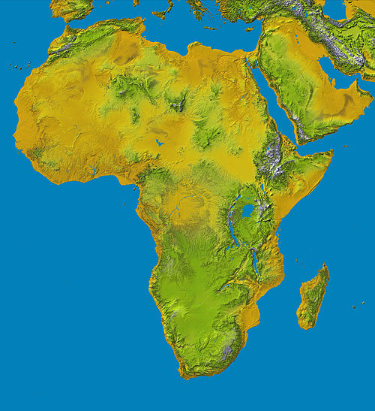

- North America
- The population was in 2026: 390.000.000
- This is 4,7% of the world population.
- In 2026 83% of the population lived in cities.
- The total land surface is around 19.000.000 km²

North America has a population of 125 million humans (5% of 2,5 billion)

In North America 125 decisionmakers are democratic elected and 7 council members.
10.000.000 km² is nature with very little limited human entrance (in such a way that nature can develop without any human influence).

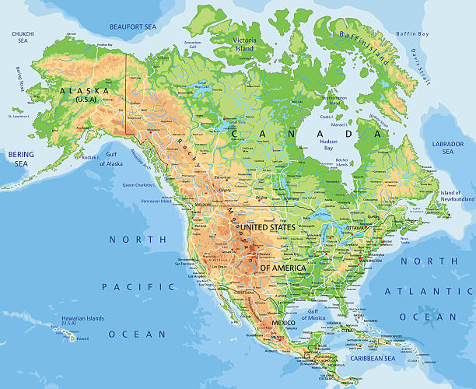
- South America
- In 2026 the population of South America was 440.000.000.
- This is 5,3 % of the world population.
- In 2026 89% of the population lived in cities
- The total land surface is 17.500.000 km².

South America has a population of 140 million humans (5,6 % of 2,5 billion)

10.000.000 km² is nature with very little limited human entrance (in such a way that nature can develop without any human influence).
In South America 140 decisionmakers and 8 council members are democratic elected.
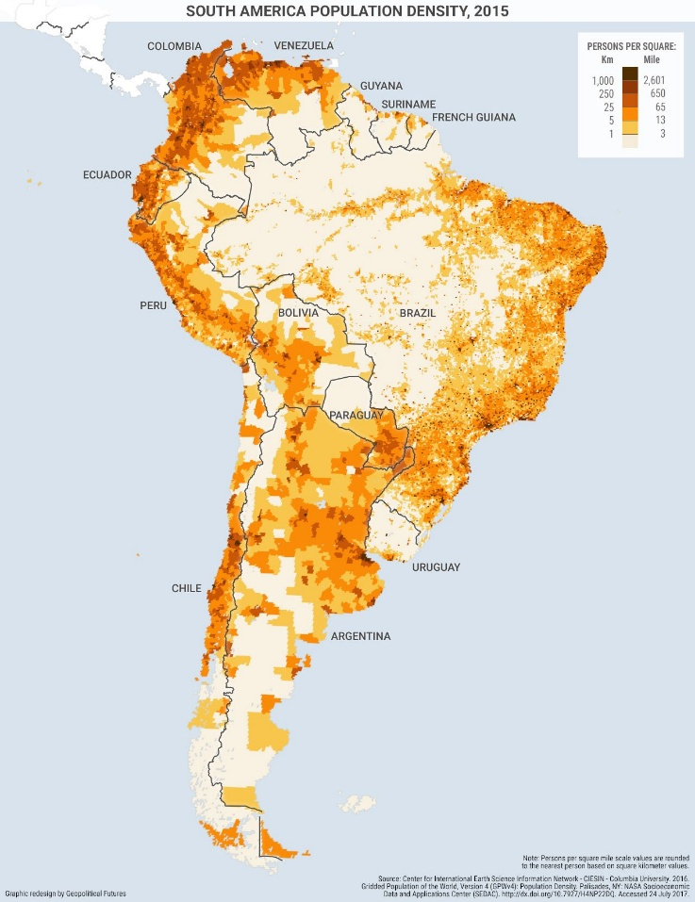

- Europe
- In 2026 the population of Europe is 745.000.000.
- This is 9% of the world population.
- In 2026 75% of the population lived in cities.
- The total land surface is 22.135.000 km².

In 2260 Europa has a population of 225 million humans (9% of 2,5 billion).
In Europe 225 decisionmakers are democratic elected and 12 council members.
5.000.000 km² is nature with very little limited human entrance (in such a way that nature can develop without any human influence).

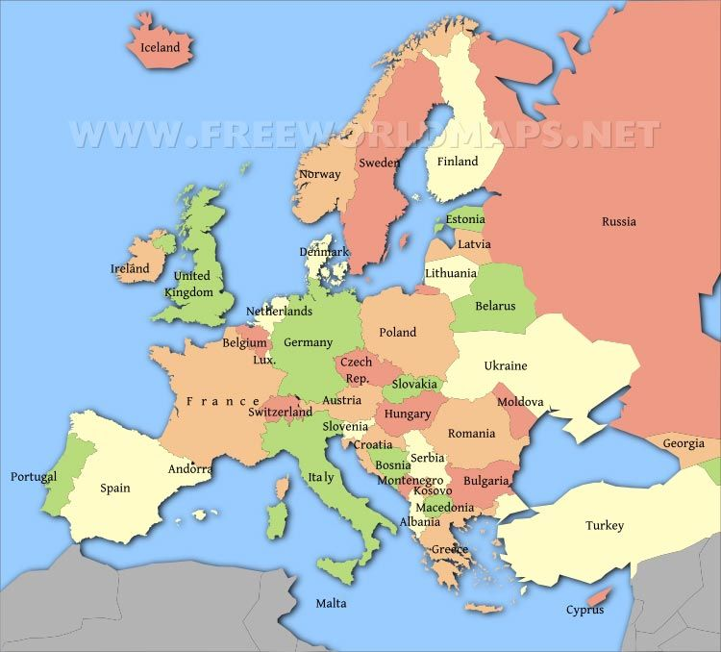

17 juni 2026

